Expert Lecture Report:
"From Idea to Reality: A Conversation with the Mother-Son Duo behind SIMPLY SALAD"

Date: April 12, 2023
Time: 3:00 PM - 5:00 PM

Introduction:
The expert lecture on "From Idea to Reality: A Conversation with the Mother-Son Duo behind SIMPLY SALAD" took place on April 12, 2023, from 3:00 PM to 5:00 PM. The event was organized by Prof. Rachana Patel, the faculty coordinator, in collaboration with the renowned entrepreneurs Payal Pathak and Soham Payal Pathak, who are the driving forces behind the successful venture, SIMPLY SALAD. The lecture aimed to provide insights into the journey of transforming an idea into a thriving business.

Chief Speakers:
Payal Pathak: Co-founder of SIMPLY SALAD
Soham Payal Pathak: Co-founder of SIMPLY SALAD

The event began with an introduction delivered by Prof. Vithlani, highlighting the importance of entrepreneurial endeavors and the significance of Payal Pathak and Soham Payal Pathak's accomplishments. Prof. Vithlani shed light on their entrepreneurial journey and emphasized the relevance of their experiences for aspiring entrepreneurs.
Payal Pathak, the co-founder of SIMPLY SALAD, then took the stage and shared the story behind the inception of their business. She discussed the challenges they faced and the strategies they employed to overcome them. Payal Pathak highlighted the importance of perseverance, adaptability, and innovation in turning an idea into a successful reality. She provided valuable insights into the decision-making process, branding, and marketing strategies that played a crucial role in SIMPLY SALAD's growth.
Following Payal Pathak's presentation, Soham Payal Pathak, the co-founder of SIMPLY SALAD, took the floor and discussed the operational aspects of their business. He shared practical tips on sourcing high-quality ingredients, building a reliable supply chain, and maintaining a consistent customer experience. Soham Payal Pathak also discussed the significance of technology and how they utilized it to streamline their operations and enhance customer satisfaction.
After the presentations by Payal Pathak and Soham Payal Pathak, the audience had the opportunity to participate in a question and answer session. This session was moderated by Prof. Rachana Patel, who encouraged attendees to ask relevant and insightful questions. The speakers addressed a wide range of queries, including topics such as scaling the business, managing finances, establishing partnerships, and sustaining growth in a competitive market.

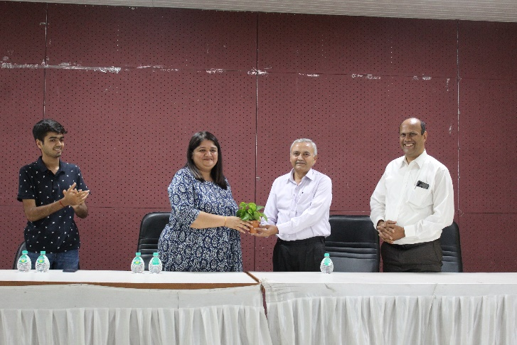 | 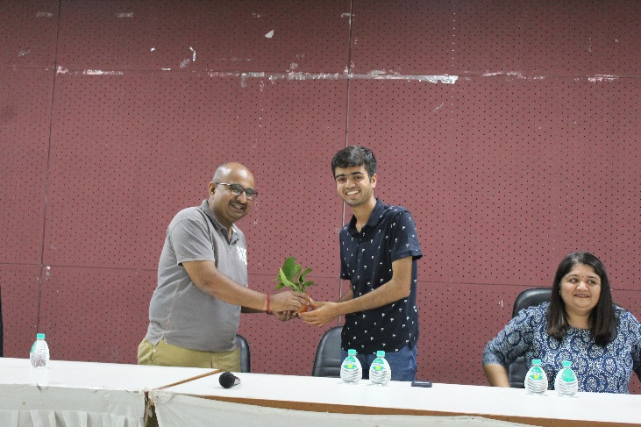
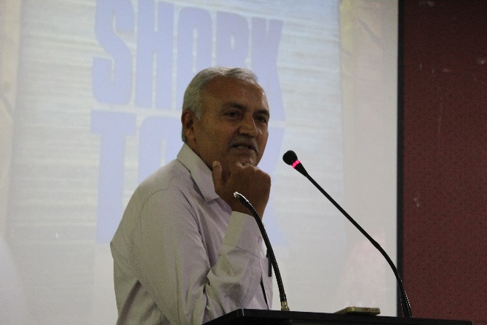 | 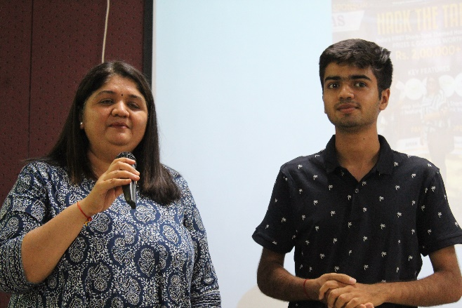
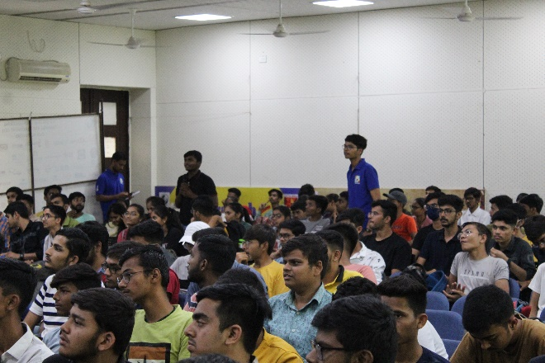 | 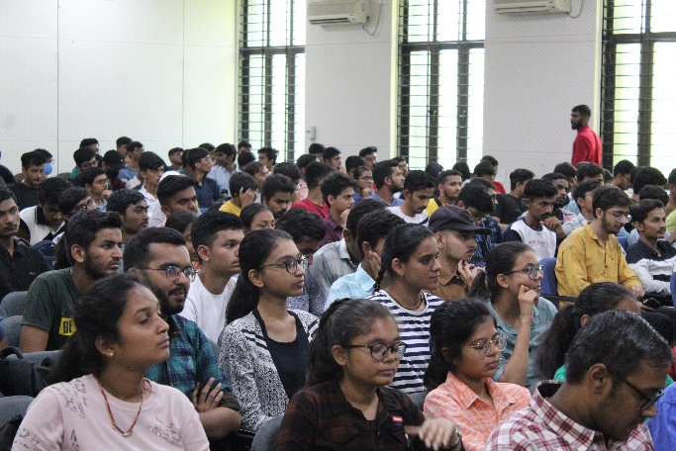

The event concluded with a vote of thanks delivered by Prof. T V Shah. He expressed his gratitude to Payal Pathak and Soham Payal Pathak for sharing their valuable experiences and insights with the audience. Prof. Shah also extended his appreciation to Prof. Vithlani for the introduction and Prof. Rachana Patel for organizing the event. He emphasized the significance of such expert lectures in fostering an entrepreneurial mindset and inspiring future generations of entrepreneurs. 10 faculty members and 150+ students have participated in the given event.
The expert lecture on "From Idea to Reality: A Conversation with the Mother-Son Duo behind SIMPLY SALAD" provided a unique opportunity for attendees to learn from the real-world experiences of successful entrepreneurs. The insights shared by Payal Pathak and Soham Payal Pathak served as valuable lessons for aspiring entrepreneurs on their own entrepreneurial journeys.

